MIXING IT UP
A Look at the Evolution of the Siphon-Bottle
Digger Odell Publication ©2004
In 1969, I was lucky enough to go to Europe for an art study program. I had been a digger for several years and had a keen interest in collecting so while there I checked every antique shop I could find. The upscale Paris antique shops had a surprising lack of bottles. However, my disappointment was soothed as I scoured the Paris flea markets and had my first experience with siphon bottles They seemed to be in great abundance and to my delight were cheap - at least until the dealers got the idea I was buying them all. Little did I know at the time, that Paris was the birth place of the Siphon
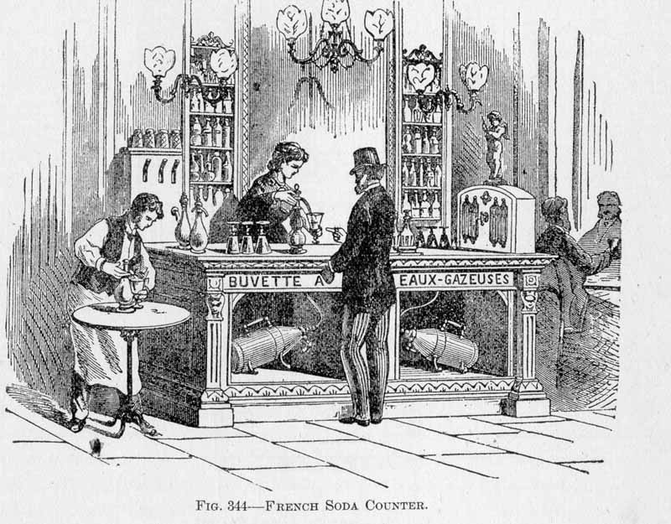
Early Siphon Experiments
An often under appreciated area of bottle collecting, these hefty but beautiful containers have a long and interesting history beginning in Europe. In turn of the century America, the drugstore soda fountain was a profitable business for dispensing flavored drinks but was practically unheard of on the Continent. Decades before Eugene Roussel, of Philadelphia, first bottled his lemon flavored soda water in 1839, Charles Plinth of England patented a soda water dispensing fountain (1813 British patent No. 3680). His device was similar to the familiar siphon bottles of the early 1900s except he used a stop-cock instead of the spring activated valve. The so called ‘Regency Portable Fountain’, circa 1825 was patented by Plinth and was the prototype of the modern siphon. Plinth however was not the only European working on the problem.

In 1829 another pair of inventors Deleuze and Dutillet, Parisian jewelers, invented a bottle, the siphon champenois, as it was called, with a hollow corkscrew which was to be inserted into the cork of the bottle and would allow for the liquid to be dispensed under its own pressure -.

The modern siphon bottle in the form we know it was developed in 1837. Called the “Vase Syphoide,” it was essentially a modern siphon, its head being fitted with a valve which was closed by a spring. It was patented by another Parisian by the name of Antoine Perpigna (Savaresse pere). These bottles became the preferred means of dispensing soda water on the Continent, favored over the individual bottle which was more popular both here and in England.
Siphons in America
The honor of the earliest patent for the self-dispensing soda bottle to the American market belongs to Alphonse Quantin of Philadelphia who in 1854 invented a metallic and gum stopper for mineral water bottles. With a little modification to the bottles of the day his invention could be attached and allow for the self dispensing of the liquid. His idea was strikingly similar to the “siphon champenois” in concept. Quantin envisioned his invention being used in homes for family use by attaching the stopper to larger bottles. The first American siphon bottle found in patent records was registered in 1869 to Joseph Bell Alexander of Washington D.C. Alexander’s improvement to the siphon bottle was in his words, | 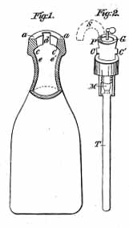  Quantin’s 1854 Patent

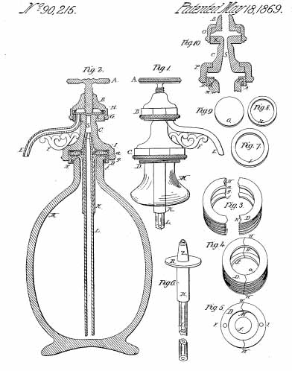 | “My invention relates to an improvement in that class of bottles called "siphon bottles," which is used for the purpose of dispensing aerated or carbonated liquids, and consists of such a construction and arrangement of the parts as will insure simplicity, ease, end quickness in the filling with liquids and tie charging with gas, and also in dispensing the 'contents when charged; also a certain security against that loss gas which occurs in all the siphon-bottles in present use, from a constant oozing through imperfect and badly constructed joints.”
He did not design the bottle but made improvement to the siphon mechanism.
All of this eventually caught the attention of John Matthews Senior, an American pioneer in the soda fountain and soda bottling industry, who took a strong interest in the siphon bottle business. Matthews was a prolific inventor - particularly of machinery relating to the soda water business. Beginning as early as 1832, he began to manufacture soda water apparatus. It was a family business by the 1860s. His son, John Matthews Junior, introduced numerous patents among which was the ‘Gravitating Stopper’ for bottles in 1864. About that time the company began producing an annual catalog advertising their equipment.. So it is no surprise that they began to advertise and sell not only siphon bottles but also the equipment for refilling the siphons. Matthews was at that time importing his siphon bottles from France. | 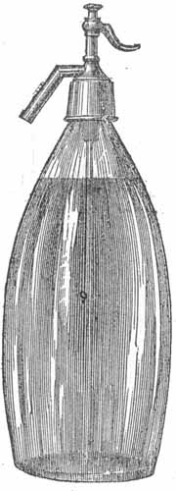  1867 Matthews Siphon Bottle was tested to 800 pounds of pressure
In fact most early siphon bottles were probably imported from France. Very shortly after Matthew’s ad appeared in 1867, others soda apparatus manufacturers too began offering siphons to the market. The Shultz and Warker advertisement shown appeared on the same page as the John Mathew’s ads.

Druggist Circular Advertising Pages April 1872
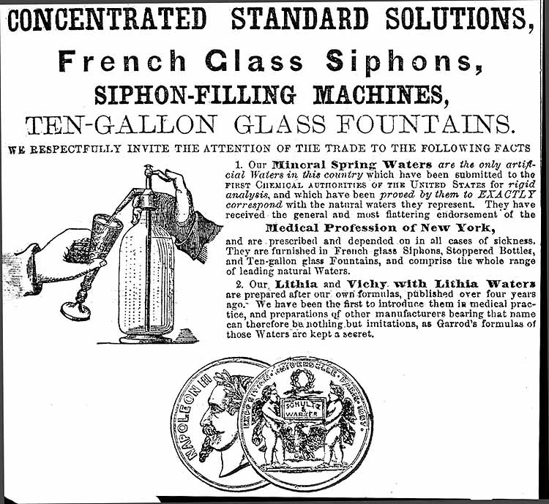

Competing Advertising
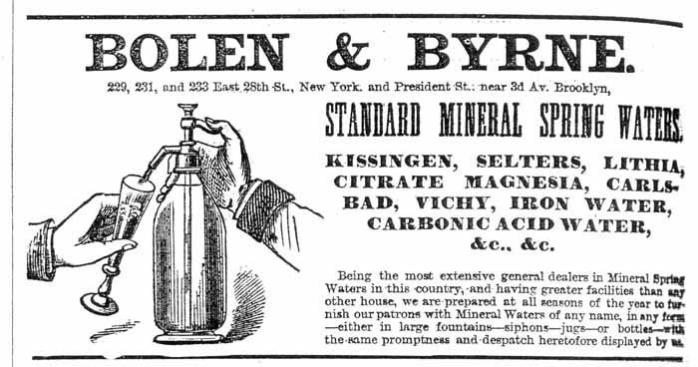
Druggist Circular 1871
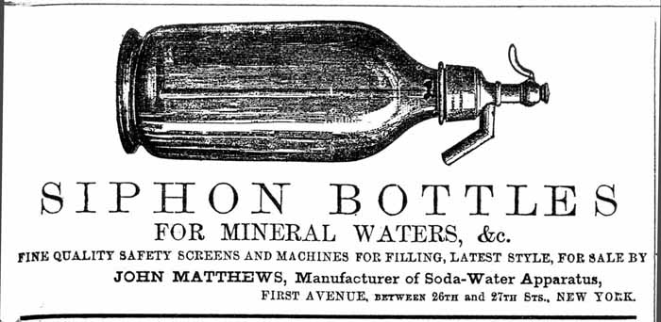
Matthews1872 Druggist Circular
The French Glass Siphons, referred to as ‘portable glass fountains’ contained artificial mineral waters and were sold to the general public and the medical profession. Schultz and Warker sold both French Siphon filling machinery and Mathews’ machinery.

Technical Difficulties
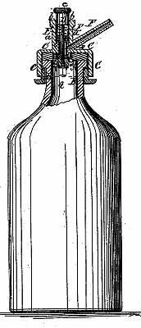  Tubeless Siphon  Schnackenberg 1868 | An early American siphon bottle was patented in 1868 by one A.D. Schnackenberg of Brooklyn, New York. He registered several patents for odd looking siphons. His design of either a glass or “stone jar” he claimed would do away with the ‘draught-tube’, the glass tube which reached down to the bottom of the bottle.. He says, “ By the use of my invention, the draught-tube is dispensed with, and thereby the expenses of the apparatus are reduced, and the bottle need not be charged so highly with the gas, as the natural weight of the liquid causes the same to be discharged when the bottle is turned around, and when the valve is opened. (apparently this was how some siphons were refilled) By requiring less gas, many accidents will be prevented, the excessive charge causing at present frequent explosions.”
Explosions were not the only problem faced by manufacturers of soda water equipment. They also were concerned with preventing metal and other materials from coming in contact with the liquid. Common materials used included, lead, tin, pewter, iron, gum, India rubber and others. Having these materials in contact with the soda water would result in the imparting of a ‘funny taste’ or worse as
Schultz and Warker said, “getting impregnated with poisonous metallic salts”. Apparently the contamination of the product by metal filings which fell into the beverage when the siphon-head was applied or tightened was a common problem. Some siphon-head makers, either unaware or uncaring, made their siphon heads of lead or metallic alloys containing lead very likely poisoning the consumers they coveted. Even other metals, like iron, posed contamination problems. Matthews was aware of these problems early and introduced a number of techniques such as coating the inside of his iron fountain reservoir with paraffin to ‘seal’ it. The myriad of problems faced by the soda apparatus entrepreneurs ensured a constant flow of new ideas and inventions into the soda water business and so it was also with siphon bottles.
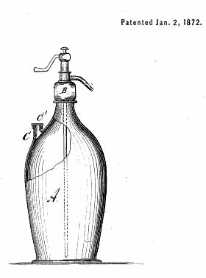  Thomas Pimer’s  1872 Improved Siphon | In 1872 another American Thomas Pimer of New London, Connecticut registered a patent for the improvement of the siphon bottle. Pimer indicated in his patent application:  “The nature of my invention consists in constructing the ordinary siphon -bottles with an extra neck, through which the bottle is filled with the liquid before the latter is charged with gas, which is forced in through the siphon after the extra neck has been hermetically sealed. The Siphon bottles now in common use are filled from the fountain through the siphon with liquid already charged with gas, and it becomes necessary in filling to let some of the gas escape from the bottle to permit the entrance of the liquid, thereby reducing the pressure be low what it should be.”
The bottles themselves were not always the problem once the design having been made of sufficiently thick glass to prevent the bottles from exploding when filled. The siphon mechanism itself however, was another story.

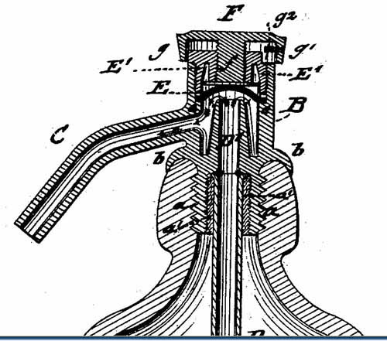 | 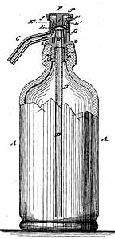

Charles De Quillfeldt of New York like Pimer was concerned with the siphon design problem of “opening and closing…in a simple and reliable manner, with less liability of the mechanism to get out of order and admit the escape of gas, as is the case in the construction heretofore employed.” His solution was to construct a “siphon-bottle, the mouth of which has an interior screw thread for screwing in the threaded shank of the siphon.” the flanged bottom of the siphon mechanism would fit tightly against the neck of the bottle.

James W. Tufts began obtained a patent for his “Artic Fountain” in 1863. He develop a good business making soda fountains and soda water apparatus. In 1888 on John Brown of Medford, Massachusetts, an assignor to James W. Tufts filed a patent for a head for siphon bottles. Like Quillfeldt and Pimer, Brown was claiming improvements for such but had no working model. In his claim he states:  “Siphon-bottles as heretofore constructed are objectionable for the reason that it is found extremely difficult to so construct the head as to cause it to bear firmly on the washer at the top of the bottle to make a perfectly gas-tight joint…. An annular space being generally left at the outside joint, between the lower edge of the head and the shoulder or flange of the collar, which space becomes filled with dirt, and more especially with the polishing powder used in cleaning the head, which is intended to be removed from the bottle after being once applied thereto." | 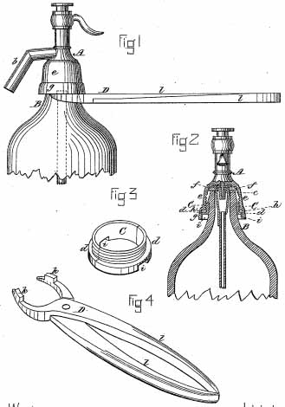  Brown’s 1888 Improved Siphon Head
Part of his idea involved the use of specially designed tongs which would be used to both hold and attach a collar. This arrangement allowed for the tightening at a later time thereby ensuring an especially gas-tight seal over time. It is interesting to note that the siphon heads once applied to the bottle were not designed to be removed even when refilling. This explains why a large number of partially full siphons bottles are found today with the non-functional heads still attached.

Oddly enough the next year, 1884, Herman Hanson and Fredrick Johnson of Medford and of Boston (likely competitors of the Tuft firm) patented a very similar siphon head to the one registered by Brown. They too were concerned with the siphon head loosening over time and the ability to tighten it.:  “It often happens that because the head is not screwed down sufficiently tight, or on account of the packing losing its elasticity by standing for a long time, these bottles leak while in the consumer’s possession, with the result that as he is usually without any suitable appliances to hold the divided ring while he screws down the head, the carbonic-acid gas continues to escape and the beverage is spoiled.”  Like’s Brown’s invention they added a collar underneath which could be tightened at a later or at refilling. Leakage and reliability were major problems for many decades. | 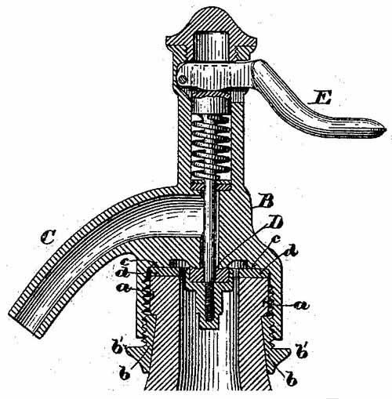  Hanson and Johnson 1884
Other design problems involved sanitation and corrosion of metal parts. In Chicago, James Shortle applied his thinking to this problem. He states:
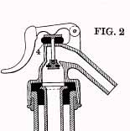  Shortle’s 1899 Glass or Porcelain Siphon-Head | “The objects of my invention are to attain simplicity and cleanliness in devices of this class; to provide a siphon-head which will be operative without the spring and spring chamber in ordinary use on devices of this class, one which may be operated with a lower gas-pressure than is required by those in ordinary use, and one in which the entire body of the siphon-head is of such simplicity that it can be readily molded from glass, porcelain or similar material; to provide for cleanliness by arranging the valve-actuating mechanism mainly outside of the body of the siphon-head.
Another inventor used a similar solution. James Wills of New York City filed his siphon-head patent in 1881 but like Shortle he had no working model. In his application he says:
“In bottles of this class it is of great importance that the liquid contained in said bottles shall not come in contact with any metallic part or parts; and for this reason I have constructed my stopper of a metallic shell, a lining of glass or equivalent vitreous material…”
How Do They Do That?
Probably the most frequently asked question about siphon bottles is how were they refilled? French, English and American manufacturers each offered their own unique refilling machines. Numerous problems presented themselves when refilling siphon bottles. Among these were the wasting of material, the difficulty of completely filling the bottle and depressing of the siphon lever to open the valve. In addition, bottles of varying sizes and shapes presented still further complications.

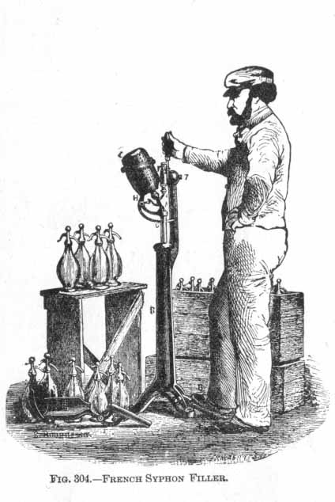 | Refilling was at best a laborious process which begged for improvement.

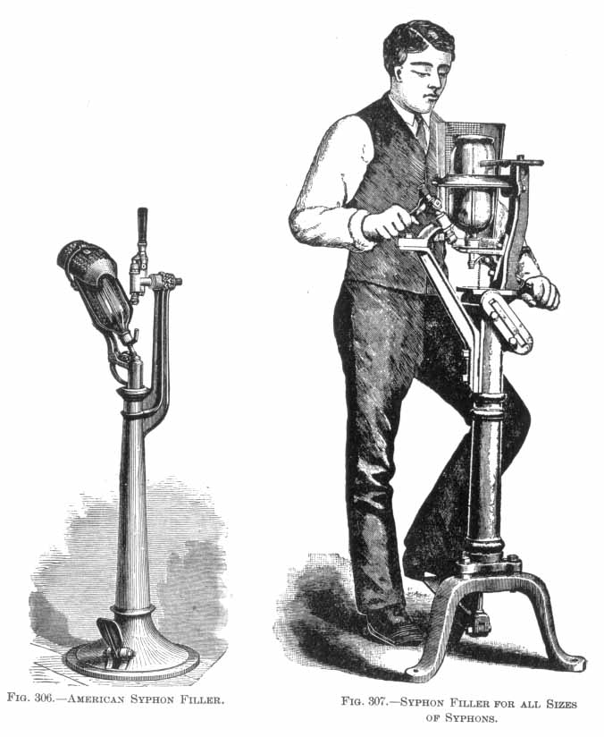

In 1868, William Gee, an early soda apparatus entrepreneur of New York City, was the first American to file a patent for a Siphon filling machine. He claimed his machine would adapt to workers of different heights, while filling bottles of different sizes and shapes without waste. Like most of the early machines, his was foot operated and had an easy means for depressing the siphon-head valve. | 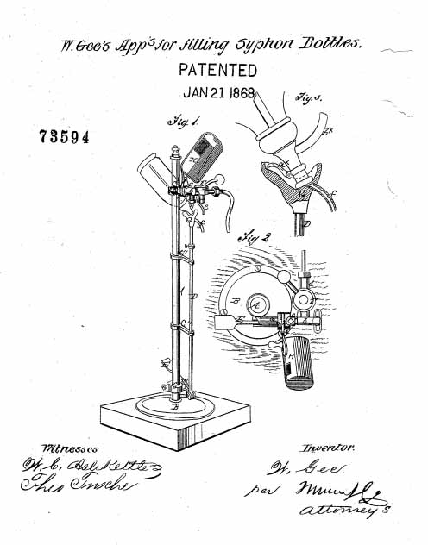
The William Clark machine of 1872. Was designed so that the gas and the water were introduced separately into the bottle. Being sealed and unable to escape, the gas carbonated the water.

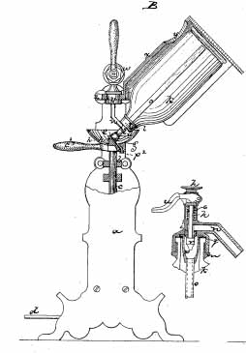  Clark’s Siphon Filling Machine 1872  George Matthews, a descendents of John, patented in a machine in 1901. In most of the later patents the inventors indicate the need for efficiency suggesting there was not much improvement in the business. | 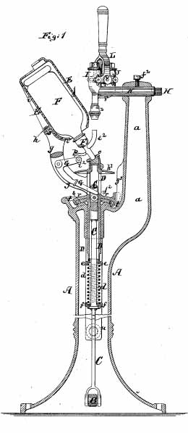  John Matthews 1884 Siphon filling Machine

John H Fox of New York City patented a table top model which :  “The object of the present invention is to furnish a simple and effective apparatus for charging ‘mineral-water siphons’ directly from the draft cock of a soda water fountain and to thus enable those who have a soda water fountain to deliver the soda water or mineral water to the consumer at a distance from the fountain.” | 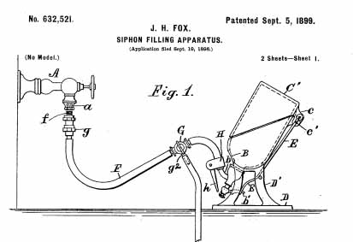  John Fox’s Table Top Model 1899

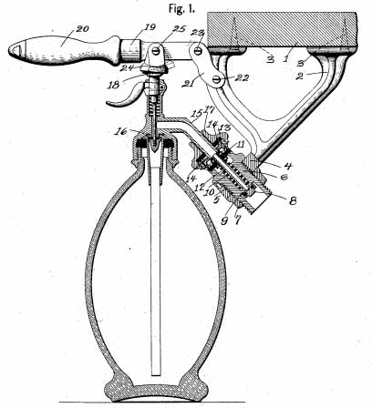 | Several inventions, such as Henry Niemeyer’s 1905 model, patented hand-operated models which may have of interest to smaller firms and local establishments. Niemeyer’s invention could hook directly to the proprietors soda fountain easily refilling the counter-top bottles.

In every case, during refilling, the siphon bottles had to be inverted to be filled and the machines could only do one bottle at a time. It was at refilling time that the bottler would clean and repair the siphon heads. It was not necessary to remove the siphon head from the bottle to accomplish this but to simply remove the small cap on the top of the head and then the interior parts became accessible. During the filling process, the siphon was placed inverted on the filling machine which was designed with a screen of some type to protect the worker should bottle explode. The siphons were never filled more than four fifth full less there would not be enough gas to dispense the liquid. The suggested filling pressure was between 120 and 140 pounds. Filling siphons never became an automated process.
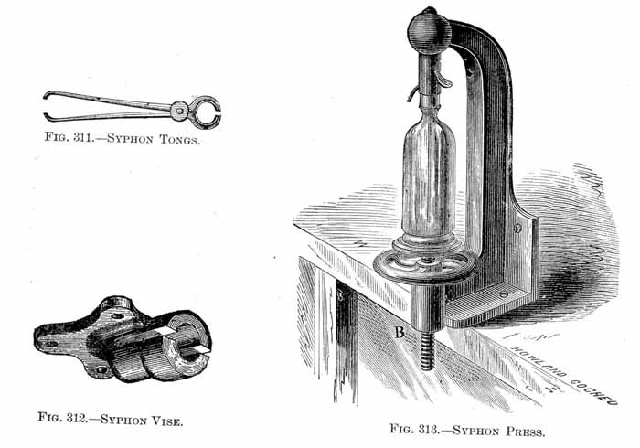
By 1900, most of the siphon bottles in America were made by Bohemian glass makers. (Bohemia is presently a region of the Czech Republic.) Improvements in bottle filling machine design continued through 1939. That no patents for machines were filed after that date suggests that the Second World War at least temporarily interfered with the siphon business. It is remarkable how little change there was in the hundred years of business.

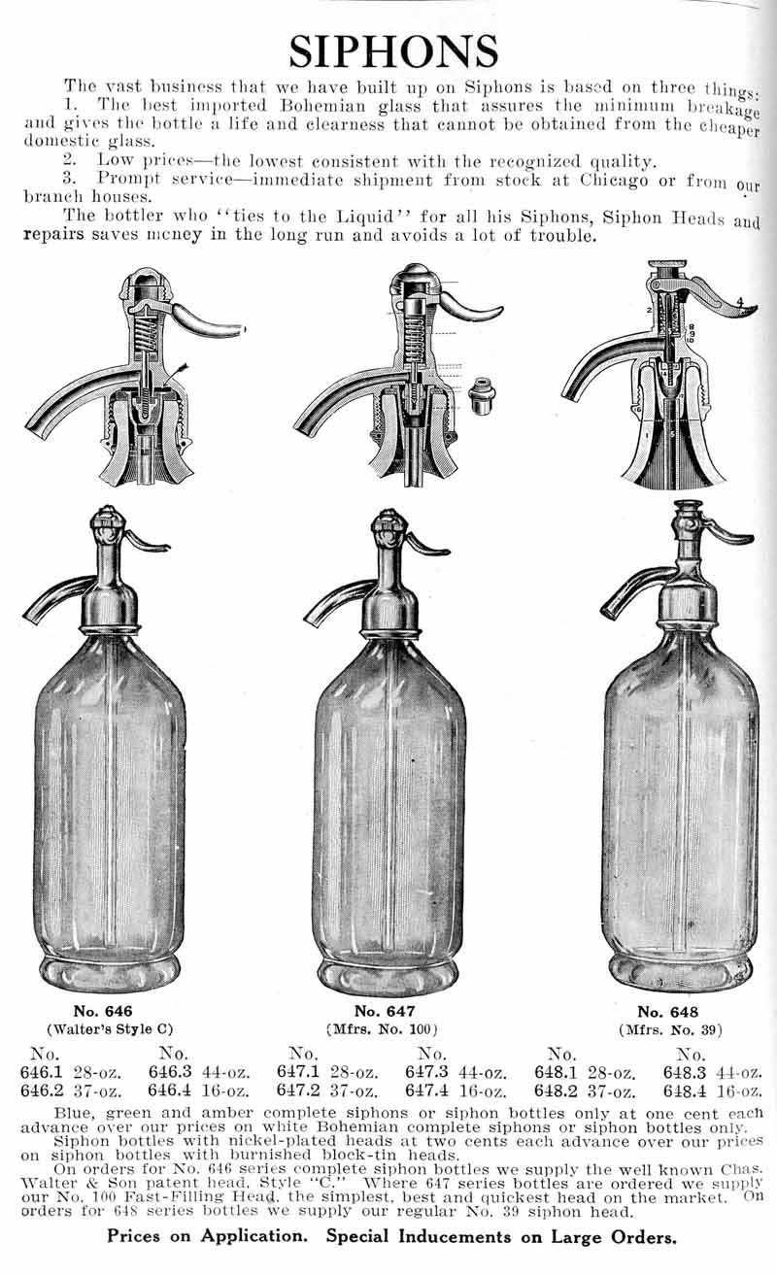
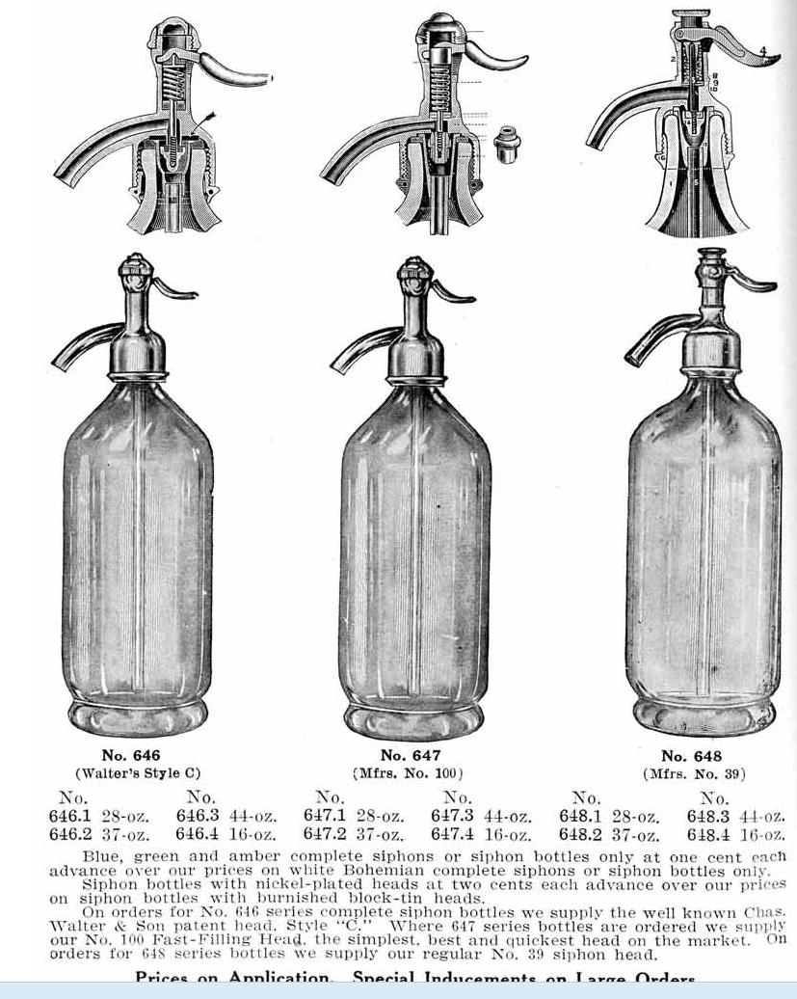

By 1900 most Siphons were Bohemian
Once the siphons were filled, they had to packed for shipping or delivery. Great care had to be taken since these bottles were under pressure and explosions were not uncommon. Specially designed boxes were used which employed wooden slats to separate the bottles. Cases were made in different sizes to accommodate the various size siphon bottles.
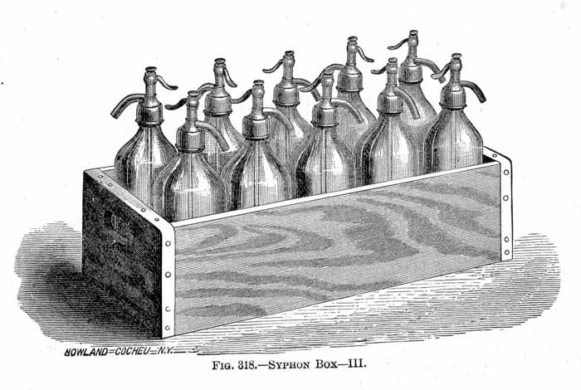

Siphon Bottles
No look at siphons would be complete without some discussion of the bottles themselves. Of all the collectible siphon bottles, the Gasogene or Seltzogene deserves the most attention. These odd looking double siphons were used from the 1880s through the turn of the century. The were almost always wicker or wire covered. There were two varieties, one French and the other English.
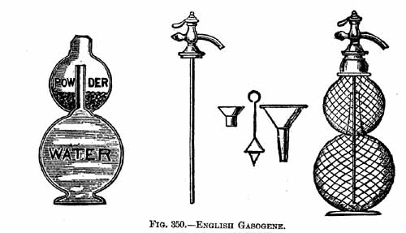

While they operated differently, they both had in common the fact that the gas was produced inside one of the two globes by means of powder such as tartaric acid on bicarbonate of soda. Gasogene were used to make sparkling wines, lemonade, cider, ginger ale or other ‘saccharine beverages (those containing sugar). Gasogenes are highly prized by collectors and relatively scarce. They were made in both quart and half gallon sizes. Sample sizes have also been reported. | 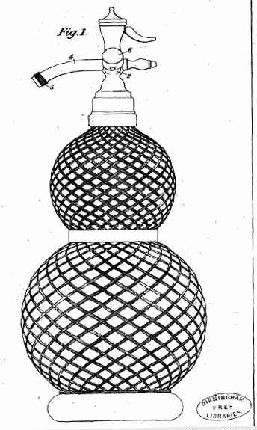  Campbell English Patent 1905
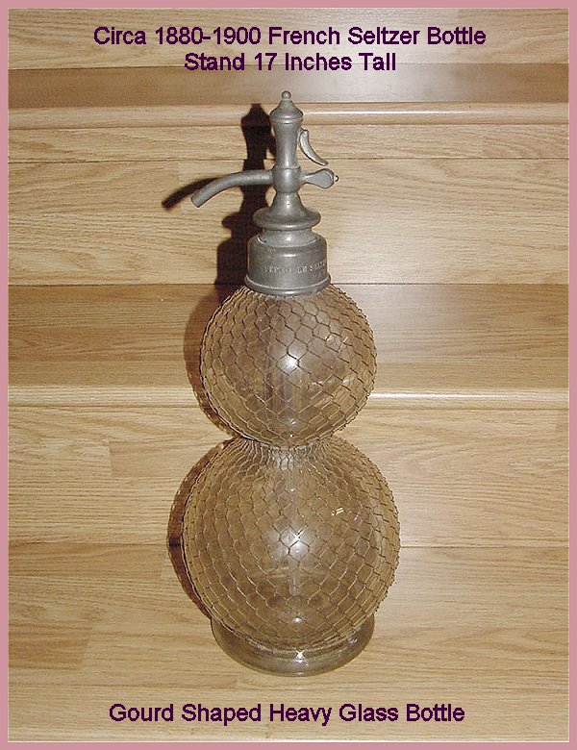
Example of a Gasogene Siphon Recently Offered on Ebay.
Photo used by permission.
Siphons bottles come in many beautiful colors and designs. Some have interior rib designs reminiscent of early American pattern mold bottles. Others have polished multi-sided designs. In nearly all cases the glass of high quality and sheen.
Colors of siphon bottles are unlike most American bottle colors. Siphons can be found in shades of blue, green, pink, vaseline, even red.
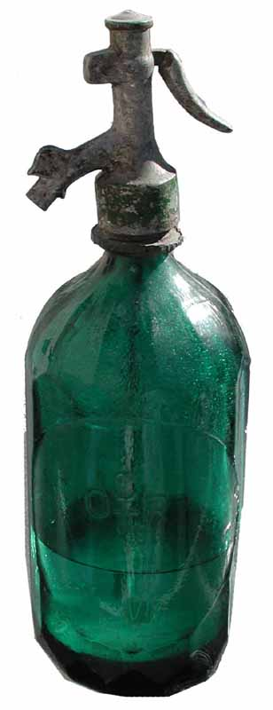
Deep Teal Green Siphon Dating in the 1880s
Probably French.

Around 1900 as the siphon became common-place in America, it became popular for companies to etch their names or even fancy monograms or logos into the glass of the siphon bottle. These bottles generally date between 1900-1930.
When the Applied Colored Label (ACL) process was invented in the early 1930s, it was not long before siphon bottle makers emblazoned their bottles with colorful labels The brightly colored labels obviated the need for highly colored bottles. Hence, ACL siphon labels are typically found on clear siphon bottles. Siphons with well known names etched or applied, like Coca Cola, bring premium prices.
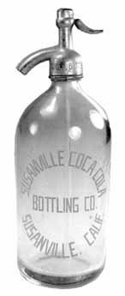 | 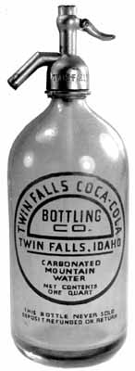 | 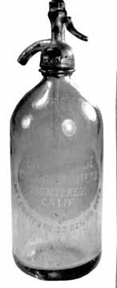
Coca Cola Siphon | Circa 1930-1940 | Acid Etched Bottles Popular 1900-1940
Customs
After scouring the Paris Flea market several times, I ended up buying about 35 siphon bottles. I shipped home two large boxes of them. The others I carried by hand, four in a hand bag and another three packed in my suitcase. When I got back to this country and was going through customs, I was immediately identified as a potential smuggler. After all I was a college student in the 1960s. The customs officer ushered me into to a private room to interrogate me.
“What do you have in the bag?’, he questioned.
“Bottles.” I said somewhat amused.
“Bottles of what?”, he persisted growing suspicious.
“Bottles of nothing.”, I replied.
“Open the bag.”, he demanded.
At first there was a uncomprehending stare on his face. When I opened the bag and showed him I had four old siphon bottles carefully wrapped and explained I collected old bottles, he motioned to me to get out. Three weeks later my other bottles arrived safely. It was a very enjoyable first experience with siphons.
Sources
- Riley, John J, A History of the American Soft Drink Industry. Arno Press. New York, 1972.
- Sulz, Charles Herman, A Ttreatise on Beverages, C.H. Sulz Co. Publisher, 1888.
- The Druggist Circular 1872-1880.
- Bottlers Machinery and Supplies, The Liquid Carbonic Co., Chicago, Illinois, Catalog 195. undated circa 1900-1910.
- United States Patent Office Records 1868-1939.
HOME

